PROJECT DEVELOPMENT PHASE
AI BLOGNEST API
Project Name | AI BlogNest API
Team ID | SWTID-2026-7288
Date | 24 September 2026
Maximum Marks | 4 Marks
Phase | Project Development

1. DEVELOPMENT OVERVIEW
AI BlogNest API was developed as a backend service for AI-assisted blogging and structured content management. The implementation uses an Express-based REST API, MongoDB access through Mongoose, Google GenAI integration, and supporting authentication, validation, security, and logging packages.
The development direction converts the earlier project requirements into reusable backend operations. The application is designed so that HTTP requests pass through the API layer, are checked by middleware, processed by application logic, and persisted through the database layer where required.
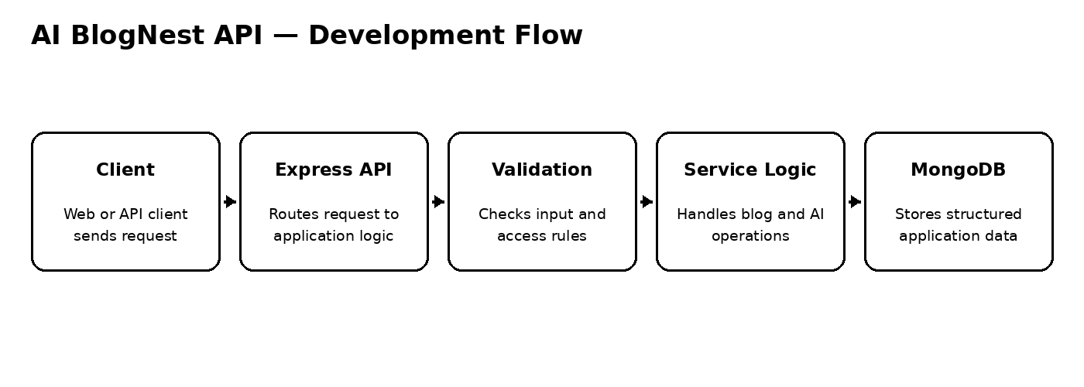
Figure 1: Development flow of the AI BlogNest API

2. DEVELOPMENT ENVIRONMENT
The supplied project configuration identifies the following development technologies:
- Node.js runtime with Express.js for the backend REST API.
- MongoDB with Mongoose for application data persistence.
- Google GenAI SDK for AI-assisted content functionality.
- JWT and bcryptjs for authentication and password protection.
- express-validator for request validation.
- Helmet, CORS, and express-rate-limit for API security and controlled access.
- Morgan for HTTP request logging.
- Slugify for readable blog identifiers.
- Nodemon for the development server workflow.
The project is configured through environment variables so database connection details, JWT settings, AI configuration, and CORS origins are not hard-coded into the application.

3. BACKEND DEVELOPMENT
The backend was implemented as a modular Express REST API. The package configuration identifies the server entry point as src/server.js and provides separate development and production start commands.

Core Development Areas
- HTTP request routing through Express.
- Application-level processing for authentication and blog/content operations.
- MongoDB interaction through Mongoose models and schemas.
- Reusable validation and security middleware.
- AI service integration through the Google GenAI SDK.
- Readable content identifiers using slug generation.
- Operational request logging with Morgan.
This arrangement keeps transport handling, data access, security processing, and AI integration conceptually separated, making the backend easier to extend.

4. AUTHENTICATION DEVELOPMENT
Authentication was designed around JWT-based access tokens and bcryptjs password protection. The development configuration includes a JWT expiry setting and a dedicated secret supplied through environment configuration.
- A registration request supplies the account information required by the application.
- The password is handled using bcryptjs rather than being stored as plain text.
- During login, the supplied credentials are checked before an access token is created.
- Protected requests carry the JWT in the Authorization header.
- Authentication middleware can verify the token before allowing access to protected operations.
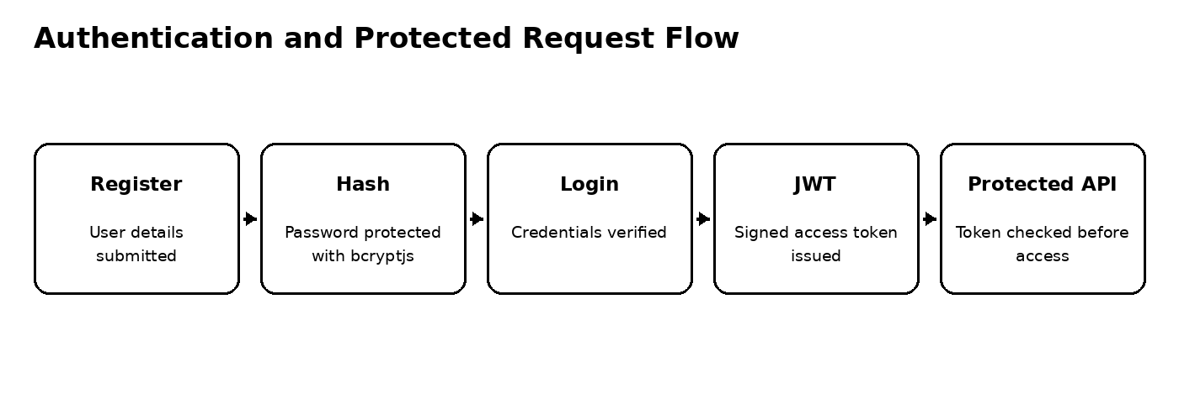
Figure 2: Authentication and protected API request flow

5. ACCESS CONTROL AND REQUEST PROTECTION
The project configuration provides several layers for controlling API access and reducing unsafe or malformed requests.
- JWT-based authentication for protected operations.
- bcryptjs for password hashing.
- express-validator for request validation.
- express-rate-limit for limiting repeated requests.
- Helmet for security-related HTTP headers.
- CORS configuration for permitted client origins.
- Environment variables for secrets and deployment-specific settings.
These controls are applied as part of the backend request pipeline rather than being treated as separate features.
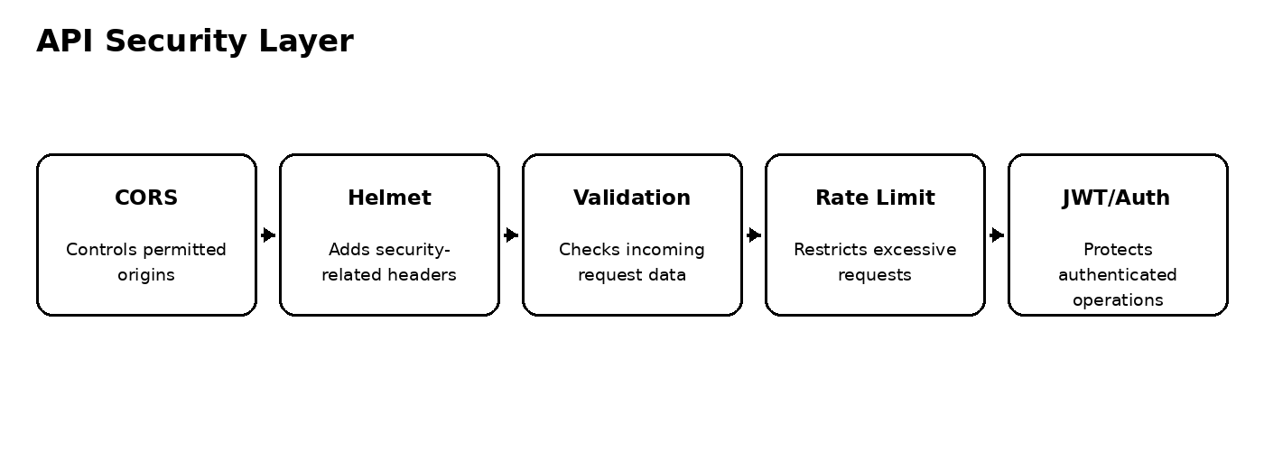
Figure 3: AI BlogNest API security and request-protection layers

6. BLOG CONTENT DEVELOPMENT
Blog content management forms the central application workflow. The backend uses MongoDB and Mongoose to support structured storage, while the API layer exposes operations for creating and working with blog content.
- Blog title and main content are handled as structured application data.
- Categories and tags support content organization.
- Slugify supports readable, URL-friendly identifiers.
- Database persistence is handled through Mongoose.
- Authentication and request validation provide controlled access to content operations.
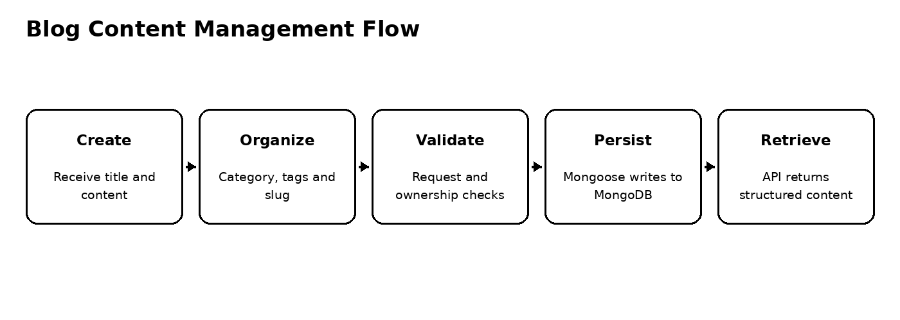
Figure 4: Blog content creation, organization and persistence flow

7. CONTENT ORGANIZATION DEVELOPMENT
The project direction includes content organization features intended to make blog information easier to maintain as the collection grows.

Organization Elements
- Categories provide a broad grouping mechanism for articles.
- Tags allow additional topic-level classification.
- Readable slugs provide stable, human-friendly content identifiers.
- MongoDB persistence keeps blog information available across API requests.
The organization layer is intentionally connected to the main blog workflow rather than being maintained as an unrelated subsystem.

8. AI-ASSISTED CONTENT DEVELOPMENT
Google GenAI is included as a core project dependency, making AI-assisted content processing part of the backend development direction. The backend can send a content request to the configured Gemini model and return the generated result to the API client.
- AI assistance can be used to reduce repetitive content-preparation work.
- The AI integration is accessed from the backend rather than exposing the provider configuration to the client.
- The model name and API key are supplied through environment configuration.
- AI responses remain part of the normal API request/response workflow.
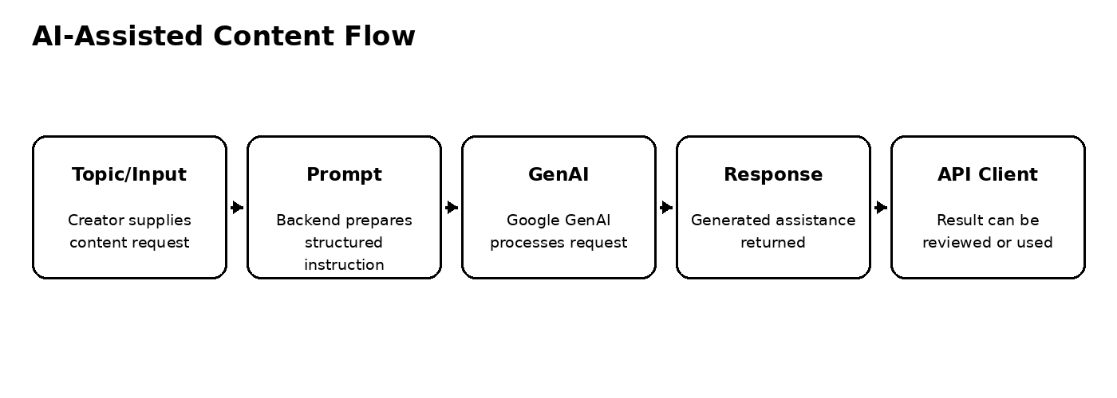
Figure 5: AI-assisted content processing flow

9. PROMPT AND AI REQUEST DEVELOPMENT
AI requests are developed around a structured backend flow in which user-provided content is transformed into an instruction for the configured Google GenAI service.
- Receive the topic, instruction, or content supplied by the API client.
- Prepare the request in the format expected by the AI service.
- Send the request through the Google GenAI SDK.
- Receive the generated response from the model.
- Return the AI result through the API response for client-side use or review.
This approach keeps AI-provider interaction within the server-side application and allows the AI layer to evolve independently from the rest of the content-management workflow.

10. DATABASE DEVELOPMENT
MongoDB is used as the persistence layer and Mongoose provides the application-facing data-access layer. This combination allows the backend to work with structured schemas while retaining MongoDB's document-oriented storage model.
- Mongoose manages database models and schema definitions.
- Blog and related content data can be persisted as MongoDB documents.
- Database access is kept behind the backend API rather than exposed directly to clients.
- The MongoDB connection is configured using an environment variable.
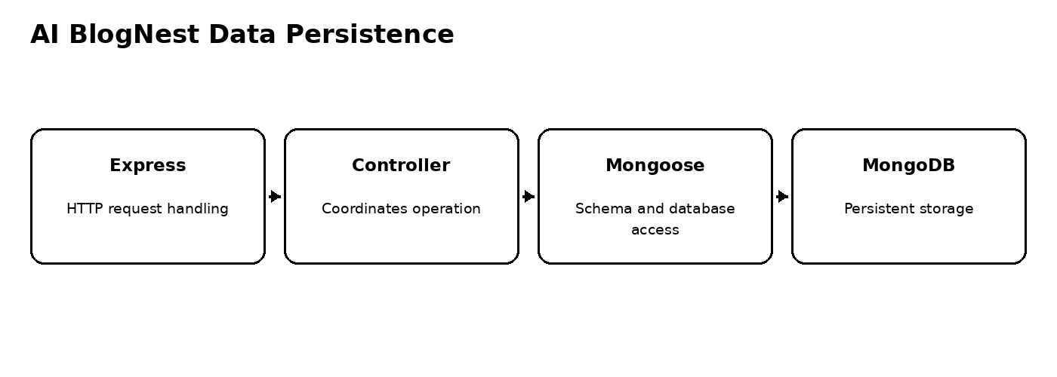
Figure 6: Express-to-MongoDB persistence flow

11. INPUT VALIDATION DEVELOPMENT
Request validation is supported through express-validator. Validation is positioned as a backend responsibility so that incoming data is checked before application logic performs sensitive operations.
- Validate incoming request fields before processing.
- Reduce malformed data entering application workflows.
- Combine validation with authentication and rate limiting.
- Keep validation rules close to the API operations that depend on them.

12. SECURITY DEVELOPMENT
Security was treated as a cross-cutting part of the backend implementation rather than a single endpoint feature.
- JWT provides authenticated request handling.
- bcryptjs protects stored passwords through hashing.
- Helmet adds HTTP security headers.
- CORS restricts browser-based cross-origin access according to configured origins.
- express-rate-limit helps control repeated requests.
- express-validator supports safer input handling.
- Sensitive configuration is supplied through environment variables.
The project environment example defines configuration for the server port, MongoDB connection, JWT settings, Gemini configuration, and CORS origins. Actual secrets are intentionally not reproduced in this document.

13. CONFIGURATION AND RUNTIME DEVELOPMENT
The project uses dotenv-based environment configuration. The supplied configuration pattern separates deployment values from application code and supports different runtime environments without changing the main source implementation.
- PORT controls the server listening port.
- MONGO_URI identifies the MongoDB connection location.
- JWT_SECRET and JWT_EXPIRES_IN control token configuration.
- GEMINI_API_KEY and GEMINI_MODEL configure the AI service.
- CORS_ORIGIN defines permitted client origins.

14. LOGGING AND DEVELOPMENT OPERATIONS
Morgan is included in the project dependencies for HTTP request logging. Nodemon is provided as a development dependency and the package scripts support a watch-based development workflow.
- Morgan records incoming HTTP request activity for development visibility.
- Nodemon supports automatic server restarts during source changes.
- Separate start and development commands keep runtime and development workflows distinct.
- A seed script is included for initializing the configured administrative data workflow.

15. API TESTING DURING DEVELOPMENT
Testing of the Project Development Phase should focus on verifying the API behaviour at the boundary where clients communicate with the backend.

Testing Areas
- Server startup and API availability.
- Registration and login flow.
- JWT-protected request handling.
- Validation of invalid or incomplete request data.
- Blog creation and content retrieval workflows.
- Category and tag-related content organization.
- AI request and response handling.
- Rate limiting and security middleware behaviour.
- MongoDB persistence and retrieval.
- CORS behaviour for configured client origins.
The reference document uses API-client testing as development evidence. For AI BlogNest, these same verification areas can be demonstrated with the API client or testing tool used during implementation.

16. TESTING RESULTS
The supplied project package establishes the development stack and scripts but does not provide a verified numerical test report in the project files available for this document. Therefore, no invented pass/fail count is included here.
The recommended final evidence for this section is the latest actual API test execution from the project environment, covering authentication, content operations, validation, AI requests, and database persistence.

17. MONGODB CONNECTION
MongoDB connection details are represented through the MONGO_URI environment variable. The application therefore keeps database configuration outside the main source code.
- Application requests reach the Express backend first.
- Relevant application logic uses Mongoose for database operations.
- MongoDB stores the persistent application data.
- Connection configuration can be changed through the environment without rewriting the application.

18. FILE STRUCTURE
The supplied package identifies src/server.js as the application entry point. The project is organized around a backend structure that can separate server startup, routes, controllers, models, services, middleware, and utility functions.
Area | Purpose
src/server.js | Application/server entry point identified by package configuration
Routes | Map HTTP requests to backend operations
Controllers | Coordinate request-level application behaviour
Models | Represent MongoDB/Mongoose data structures
Services | Hold reusable business or integration logic
Middleware | Authentication, validation, rate limiting and related request processing
Utils | Supporting functions and project utilities
The exact implementation tree should be kept synchronized with the current source repository. The description above follows the modular structure established for the AI BlogNest backend and avoids exposing environment secrets.

19. DEVELOPMENT OUTCOME
The Project Development Phase converted the AI BlogNest design direction into a backend implementation centered on REST APIs, structured content storage, AI assistance, and API protection.
- Express-based REST backend with a defined server entry point.
- MongoDB persistence through Mongoose.
- JWT authentication and bcryptjs password protection.
- Validation, CORS, Helmet, and rate limiting for request protection.
- Blog content organization using categories, tags, and readable slugs.
- Google GenAI integration configured through environment settings.
- Morgan request logging and Nodemon development support.
- A modular foundation that can be extended with additional content and AI capabilities.

CONCLUSION
The Project Development Phase established a working technical foundation for AI BlogNest API by turning the earlier design direction into a backend-oriented implementation. The project combines Express.js, MongoDB/Mongoose, Google GenAI, JWT authentication, bcryptjs, validation, security middleware, and environment-based configuration within a single API workflow.
Rather than treating AI assistance and blog management as separate utilities, the implementation places them behind the same controlled backend. This provides a consistent path for handling requests, validating input, protecting access, processing content, communicating with the AI service, and persisting application data.
The resulting development foundation is suitable for continued expansion of AI-assisted blogging, content organization, and API capabilities. The phase therefore provides the technical base required for subsequent testing, refinement, and deployment activities while keeping security and maintainability part of the development process.

